Code Review: I2301120
Reviewer: Mark Dell
Date: May 15th, 2023

Bugs

Preventative Action/Safety

Design/Architecture (Duplication, appropriate project, namespaces, maintainability)

Data Model (Naming, good design, needs index?)

Performance (Minimize DB hits, excessive loops, queries, scalable)

UI (Alignment, naming, standardization, tab order)

Error Handling (Behind events, appropriate parameter checking)

Cleanup (Dispose code, remove handlers, large data objects)

* Readability (Well-named variables, methods, clear algorithm, is it understandable)
- Nit: Since I find spacing improves this, I usually add a line break before Try, If, Do, While, Else, and ElseIf type statements if they are not indented from the previous line. I also add one after Variable Declarations anywhere within the method. I may exclude doing that for Else statements when the “If” is very small and not solely contained within another structure. This is one of the examples I saw. I would not have used this as an example if you did not add newlines here.
Example:
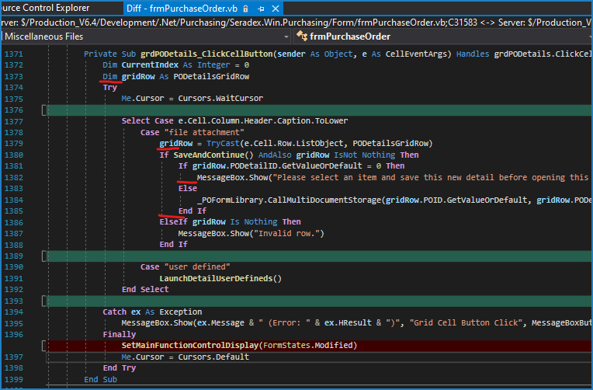

Comments (Useful, explains why rather than how)

Message Boxes (Grammar, spelling, captions, appropriate icons)

Ticket Management (Release Branch?, Testing Notes)

* Extras
- Nit?: sxLengthNullSafe is no longer needed for If statements (as well as sxTrimLengthNullSafe) that perform this kind of check. I usually also do a “not equals” check, instead of a positive check since it is a simpler check for the CPU. “Is any bit different?” vs “Is the sign bit off and anything else different?”.
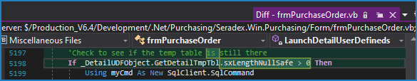
This works perfectly instead: If _DetailUDFObject.GetDetailTmpTbl?.Length <> 0 Then (or ?.Trim?.Length)

